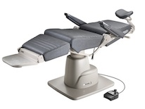6200 Exam Chair Details

Features

The Model 6200 is designed for efficient operation from both sides of the chair.

Ergonomic design facilitates contact with patient and eliminates wasted movements.

Maintain contact with patient during all chair functions.

High and low base models available.

Power hydraulic lift raises patient with a bump-free, quiet ride.

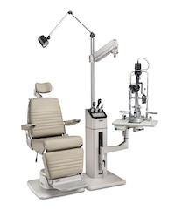

Membrane Switches are engineered for reliable performance year after year.

A recline bar, reachable from both sides of the chair top, activates the chair's counterbalanced recline.

Concave upholstered headrest is standard. Wide range of vertical and axial positions. Check for other headrest options.

Made in America and CSA, C/US Certificate of Compliance.